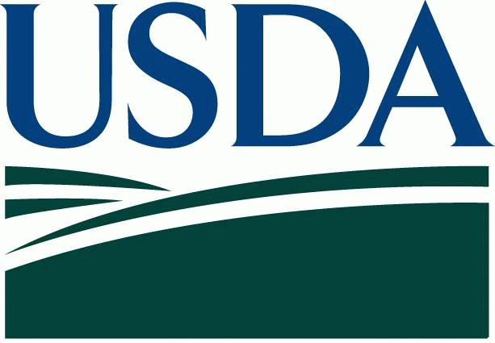
United States Department of Agriculture FACT SHEET
September 2020
Fire Recovery Assistance from the California Farm Service Agency

The U.S. Department of Agriculture (USDA) California Farm Service Agency provides assistance to help farmers, ranchers recover from natural disasters, such as wildfires. Listed below is an overview of applicable programs.

- Livestock Indemnity Program (LIP): Compensates producers for livestock death due to natural disasters. Compensation is based on roughly 75percent of the national average price of the livestock by type and age. Report losses within 30 days. Complete applications are due 60 days after the end of the calendar year.

- Emergency Livestock Assistance Program (ELAP): Compensates producers for a percentage of the pasture or forage loss on private lands due to natural disasters. Payments are subject to a national payment factor. Report losses within 30 days. Complete applications are due 30 days after the end of the calendar year.

- Livestock Forage Disaster Program (LFP): Compensates producers who suffer pasture or forage loss due to drought or who have federally managed grazing leases but are not allowed to graze the lease because of wildfire. Report losses within 30 days. Complete applications are due 30 days after the end of the calendar year.

- Emergency Loans – low interest loans to replace farm and ranch buildings and structures, make repairs or replace livestock or feed. Must meet disaster/emergency criteria.

- Emergency Conservation Program (ECP): is administered by the U.S. Department of Agriculture (USDA) Farm Service Agency (FSA), provides emergency funding and technical assistance to farmers and ranchers to rehabilitate farmland and conservation structures including fences damaged by natural disasters and implement emergency water conservation measures in periods of severe drought.
- Emergency Forest Restoration Program (EFRP): Provides payments to nonindustrial private forest landowners for emergency measures to restore land damaged by a natural disaster. This program is contingent on funding available.
- Tree Assistance Program (TAP): Provides financial assistance to replant or rehabilitate eligible trees, bushes and vines damaged by natural disasters. Forests are not eligible.

- Non-Insured Crop Disaster Assistance Program (NAP): Provides compensation to producers who grow uninsurable crops and have purchased NAP coverage by the crop signup dates.

- FSA offers many programs to help producers recover from losses, including the Livestock Indemnity Program (LIP), the Emergency Assistance for Livestock, Honeybees, and Farm-Raised Fish Program (ELAP), Emergency Forest Restoration Program and the Tree Assistance Program. Producers located in counties receiving a primary or contiguous disaster designation are eligible for low-interest emergency loans to help them recover from production and physical losses. For more information, visit http://disaster.fsa.usda.gov

California Farm Service Agency Contacts: Wildfire Region 2020 D3 & D2

Farm Service Agency - State Office
430 G St. Ste 4161
Davis, CA 95616
530-792-5520

San Joaquin / Alameda /Calaveras / Contra Costa /San Francisco
7585 S. Longe #100
Stockton, CA 95206
(209) 337-2124

Stanislaus / Tuolumne
3800 Cornucopia Way, Ste.E
Modesto, CA 95358-9492
(209) 491-9320

Monterey / San Mateo / Santa Cruz
744 LaGuardia St. Ste. A
Salinas, CA 93905
(831) 424-7377

San Benito / Santa Clara
2337 Technology Parkway, Ste A
Hollister, CA 95023-2544
(831) 637-4360

Sonoma / Marin
5401 Old Redwood Highway
Suite 100.
Petaluma, CA 94954
(707) 664-8593

Solano / Napa
810 Vaca Valley Pkwy. Ste. 102
Vacaville, CA 95688
(707) 448-0106

